**PROJECT REPORT**

**ON**

**TOURISM MANAGEMENT SYSTEM**

Submitted By,

PALURU SRAVANI (845266)

Batch Code: CHN19AJ029

**LIST OF CONTENTS: PAGE NO:**

1. ABSTRACT 3

2. INTRODUCTION 4

3. REQUIREMENT SPECIFICATION 5

4. ARCHIRECTURE DESIGN 6-7

5. OUTPUT 8-11

6 CONCLUSION AND FUTURE WORK 12

7. REFERENCES 13

**1. ABSTRACT:**

The recent past showed a greater interest in recommender techniques. Now-a-days there are many travel packages existing from different websites to almost all the places over the world. A customer finds it very difficult to search for the best package as he/she has to browse multiple websites, contact many travel agents and etc. which is a tedious process and is time consuming. There should be a system where the user should find the best package on the Internet with a single click.

To address this issue, we adopt Tourism Management System which offers the best package among all the other packages that are on the web. This project will help tourist to suggest the best Travel Package among all the package deals on the web. On multiple demands of tourist that is, a customer will select a travel package for a particular place based on the price, date availability. Therefore, according to the personalized recommendations, he/she will choose the best package that is on the web.

**2.INTRODUCTION:**

Tourism can be considered as most favorite pass time when people get free time. Several travel organizations are available on the web. The people or the tourist select their own Travel Package according to their personal interest. The travel companies concentrate on the interest associated with tourist making sure to increase their particular market value and supply enormous package deals. So that they can make their Travel Package more effective. Now-adays Recommender system is becoming very famous and people are getting attracted to it, as it is helping them to choose the best package in a short time.

**3.REQUIREMENT SPECIFICATION:**

Operating System : Windows

Technology : Java and J2EE

Web Technologies : CSS

IDE : Eclipse(Maven 3.0 or above)

Web Server : Tomcat 7.0 or above

Database : MySql 5.0

**4.ARCHITECTURE DESIGN:**

Design of the new system begins by elaborating the statement of requirements in terms of more detailed objectives. The main aim of design process is to produce a model or representation of the system, which can be used later to bind the system. The produced model is called design/architecture of the system. A system design is a top down approach to minimize complexity and make a problem manageable by subdividing it into smaller segments. The most changing phase of the system development of life cycle is system design. It refers to the technical specification that will be applied in implementing the candidate system. The potential objects are thoroughly analyzed. Class hierarchies are to check whether the system is behaving the way it has to. There after the classes are individually tested and subsequently they are integrated from the overall system.

**Project Flow:**

1) The client sends an HTTP request to a specific URL, Dispatcher-Servlet of Spring MVC receives the request It passes the request to a specific controller depending on the URL requested using @Controller and @RequestMapping annotations. 2) Spring MVC Controller then returns a logical view name and model to Dispatcher-Servlet. 3) Dispatcher-Servlet consults view resolvers until actual View is determined to render the output. 4) Dispatcher-Servlet contacts the chosen view (like Thymeleaf, Freemarker, JSP) with model data and it renders the output depending on the model data The rendered output is returned to the client as a response

**Project Flow Diagram**

It shows the functional component in the software package. 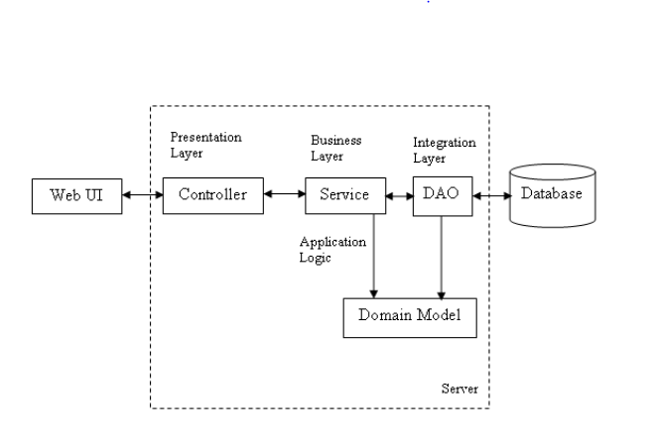

**Fig. Project Flow Diagram**

**5.OUTPUT:**

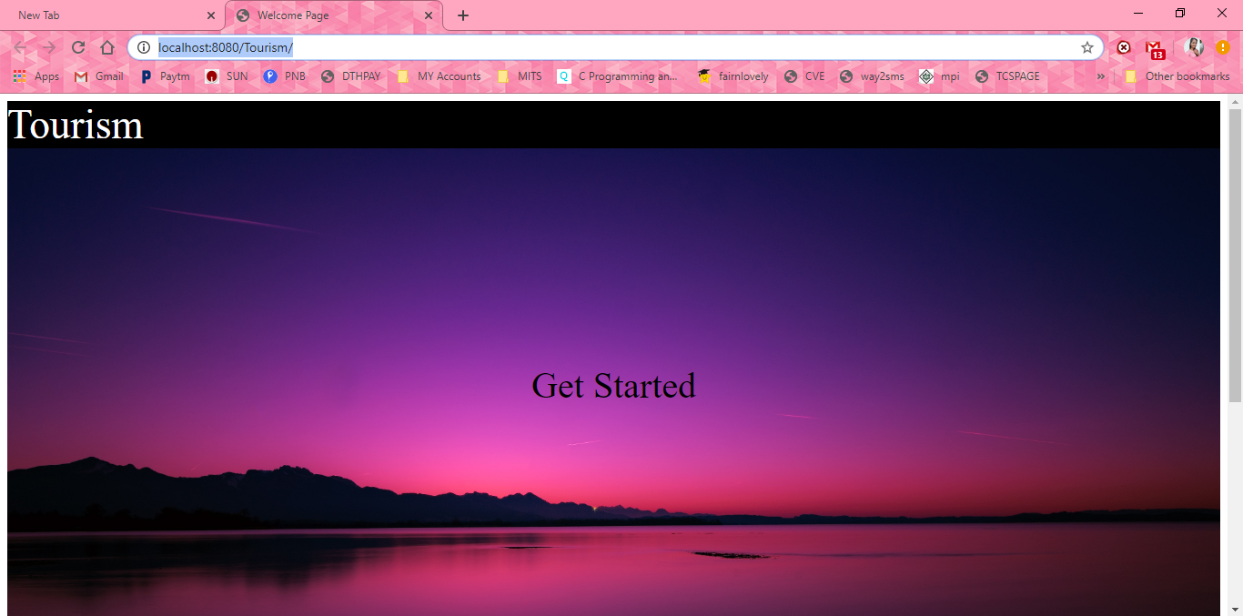

**Fig. Home Page**

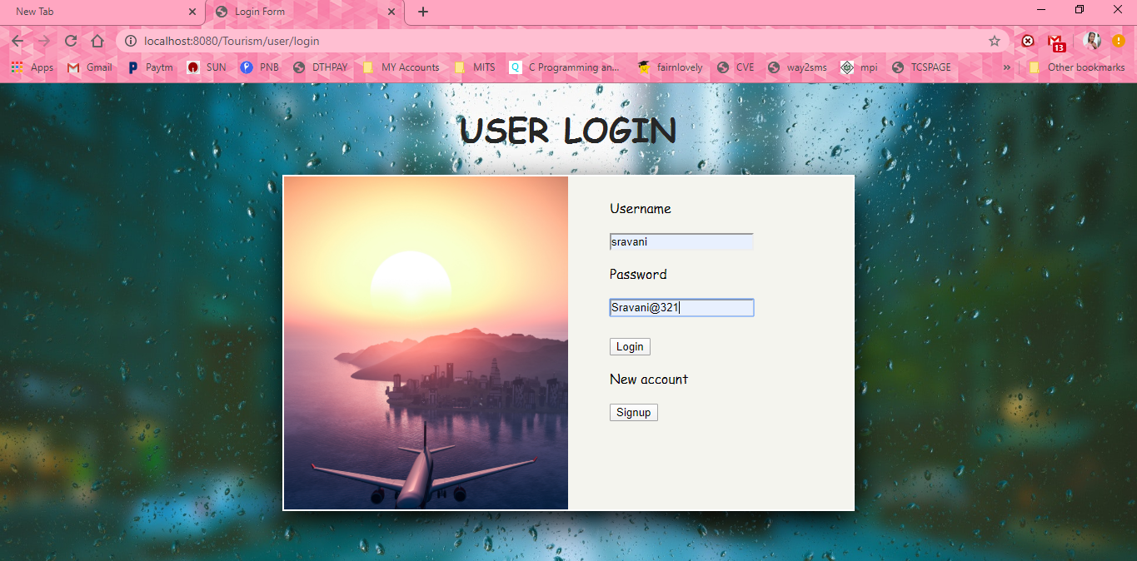

**Fig. Login Page**

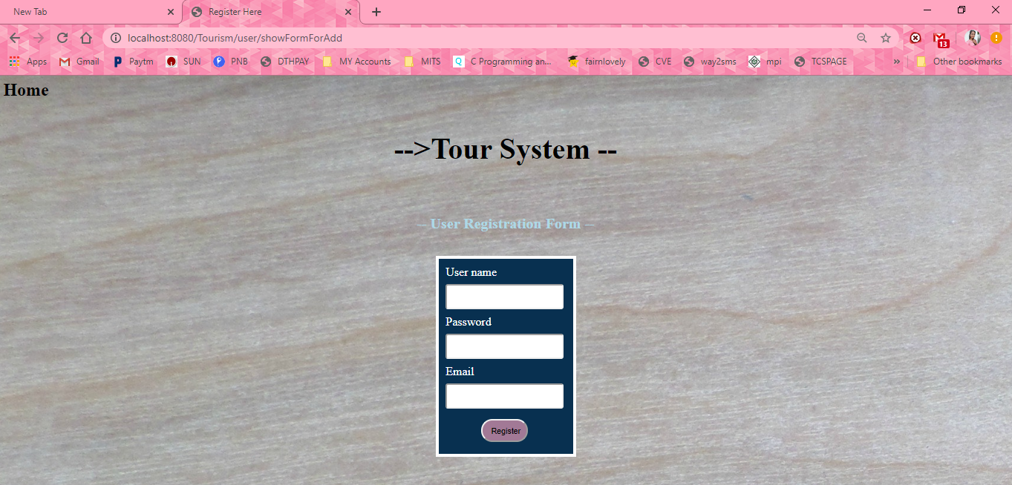

**Fig. User Registration form**

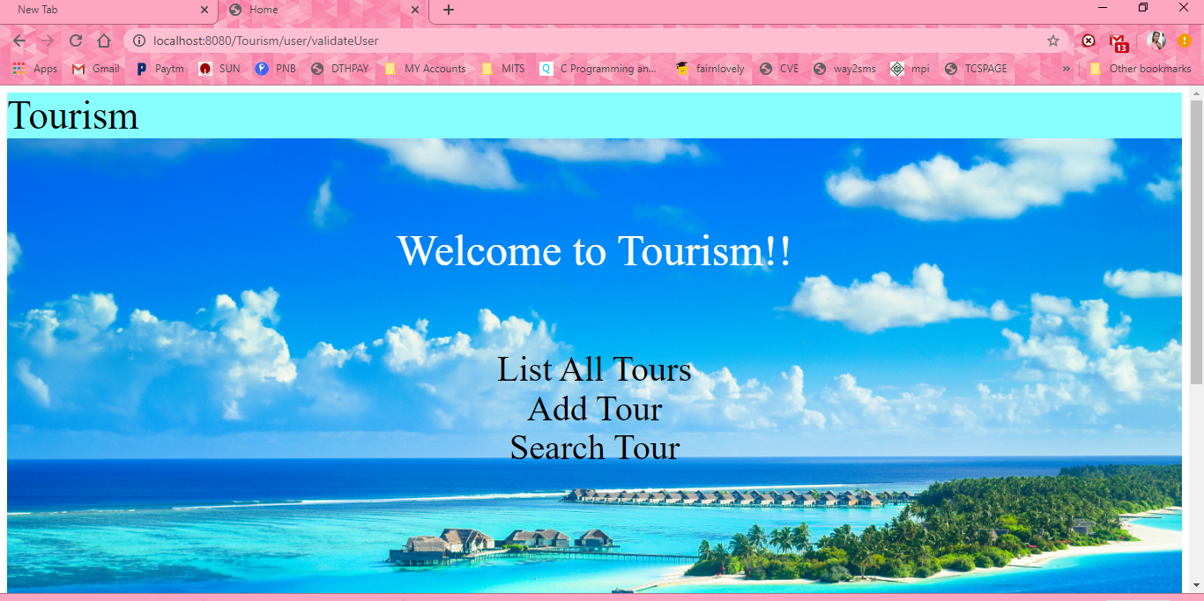

**Fig. Main Page**

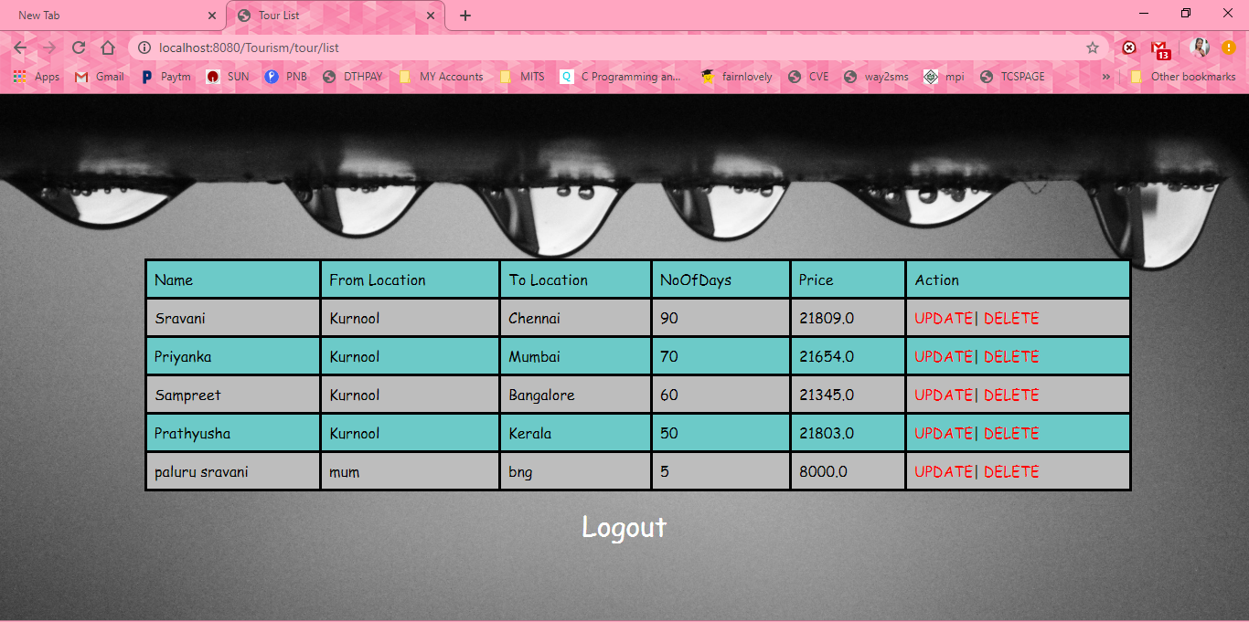

**Fig. List of Tour Packages**

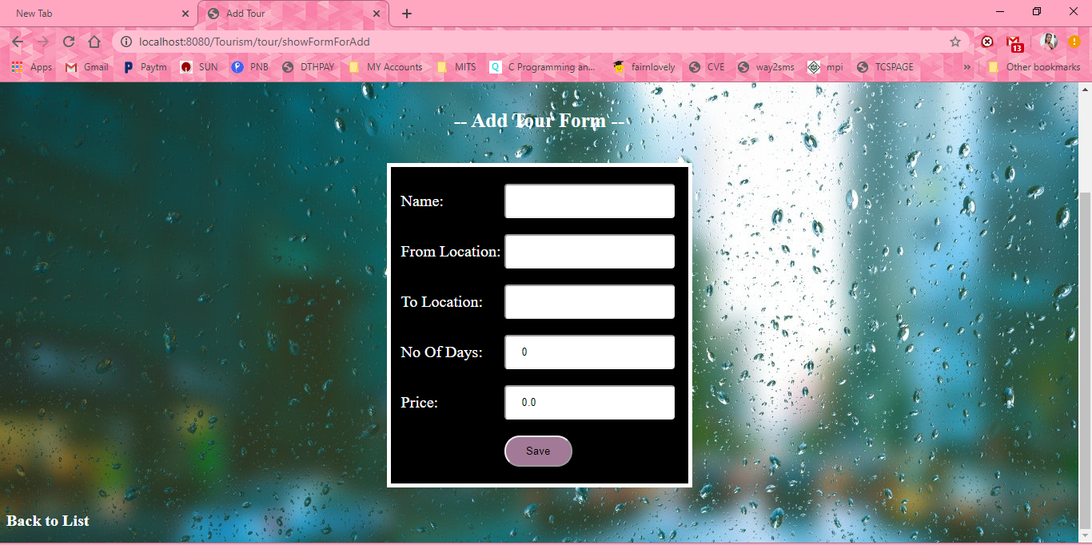

**Fig. Add New Tour Package**

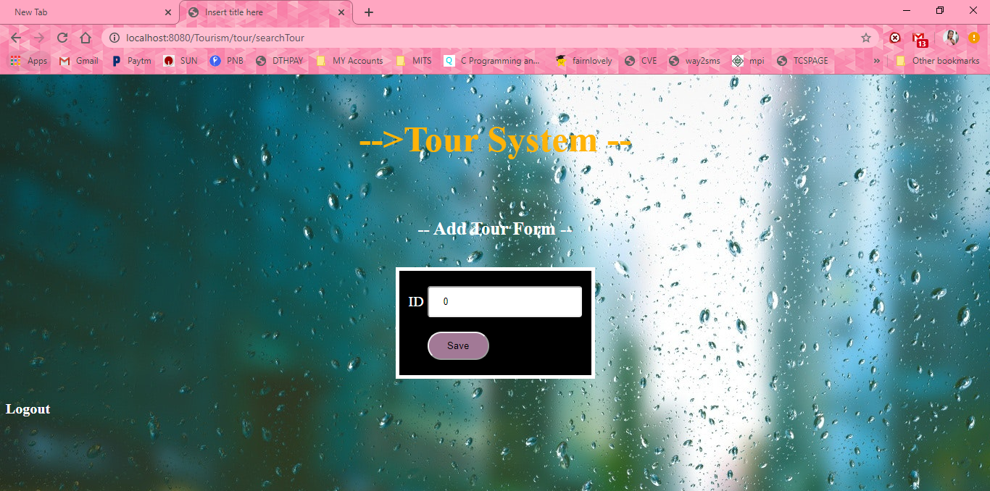

**Fig. Search a Tour**

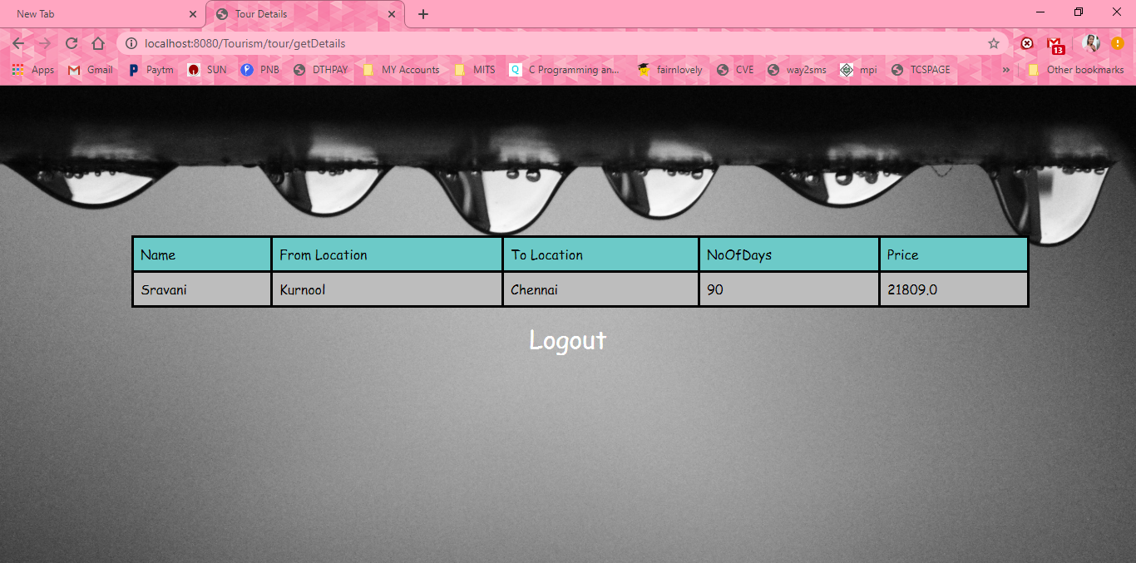

**Fig. Tour Details**

**6. CONCLUSION AND FUTURE WORK:**

This project will help to suggest the Travel package deals on the web. In this, a customer will select a travel package for a particular place will select a travel package for a particular place based on the price, availability of date. This makes easy for the user to choose the best package deal. The user can select the best package in short amount of time (instead of navigating to other websites). Finally, the goal of the project is to make an efficient system which is effective in terms of cost and money.

**7.REFERENCES:**

1.https://docs.spring.io/spring/docs/current/spring-framework-reference/

2.https://docs.spring.io/spring/docs/current/spring-framework- reference/core.html#spring-core

3.https://docs.spring.io/spring/docs/current/spring-framework-reference/web.html

4.https://hibernate.org/orm/documentation/5.0/

5.https://maven.apache.org/guides/getting-started/index.html